**I. A quadratic is polynomial with the highest degree of 2 or second degree**.

Definition Form: 

Ex. 

**II. Quadratic Expression:**

***Simplify it only***! (No equal signs therefore, you can not solve for X!)



**III. Quadratic Equation:**

***Solve it!*** Solve for X. (Equation is equal to zero)



*Can be solved in order to find the ROOTS of the equation. ***Roots are also called ZEROS or X-INTERCEPTS***

**IV. Different methods of Solving a Quadratic Equation: (Algebraically)**

**1. Factoring:**

If ab = 0, then a = 0 or b = 0



**2. Square Root Principle:**

If 



**3. Completing the Square:**

 

**4. Quadratic Formula:**

 

**V. Quadratic Function:**

***Graph it!*** (Remember: A function is where each X value must be matched with only one Y value).



**\*A Quadratic Function is a Parabola Graph**

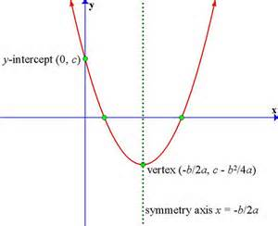

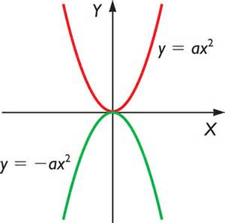

1. Notice that when the Parabola ***opens upward, ax2 is Positive*** (+ax or a > 0) and when the Parabola ***opens downward, ax2 is Negative*** (-ax or a< 0).

2. All Parabola have a ***Vertex*** with a ***Maximum*** (Highest point) and ***Minimum*** Point (Lowest point).

3. All Parabolas are symmetric with respect to a line called ***Axis of Symmetry*** or simply the axis of the parabola. The point where the axis intersects the parabola is the vertex of the parabola.

X = Axis of Symmetry

*Axis of symmetry is not part of the graph itself, but its important in that the parabola creates a mirrored image.

4. **Definition** of Quadratic Function is , however the **Standard Form** of a Quadratic Function is:



5. Finding Vertex (h, k):

a) If Quadratic function is in Definition form:





b) If Quadratic Function is in Standard form:



c) If vertex is not in the form  then you can use the method of ***Completing the Square*** to change the equation into ***Vertex Form.***

6. There is only ***ONE Y-Intercept***, but there are either ***NO, ONE, OR TWO X-Intercepts***.

7. Graphs of Quadratic Functions:

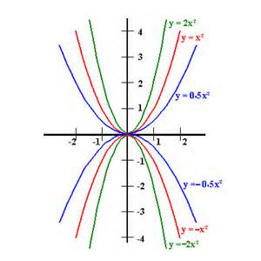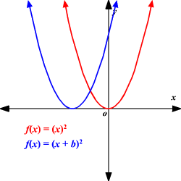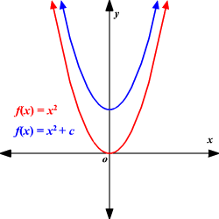

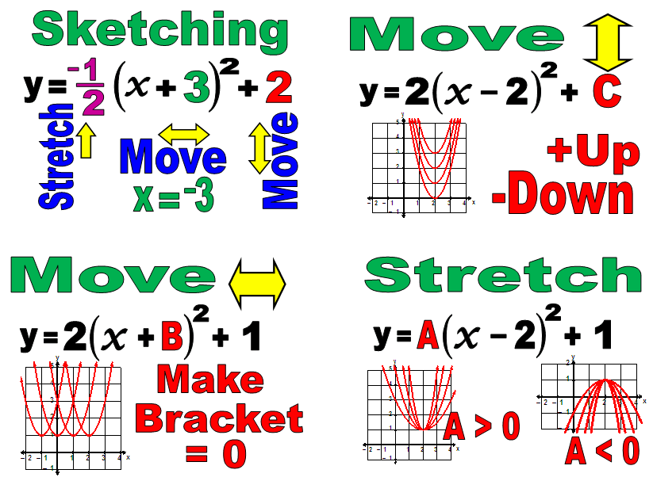

**GRAPHING A QUADRATIC FUNCTION**

1. Does the graph curve up or down?

a < 0 or a > 0

2. Find Vertex:

1) Is it in Standard form or (Vertex Form)?



2) Is it in Definition of Quadratic Form?



3. Find Y-Intercepts:

Replace X with 0.

 

4. Find X-Intercepts:

a) Solve  by using either ***FACTORING, SQUARE ROOT PRINCIPLE, COMPLETING THE SQUARE, OR QUADRATIC FORMULA.***

b) Find X-Intercepts where graph crosses the x-axis and y=0.

5. Graph the quadratic and find Axis of Symmetry